Development - Force Sensitive Resistor Evaluation
Experiment Description
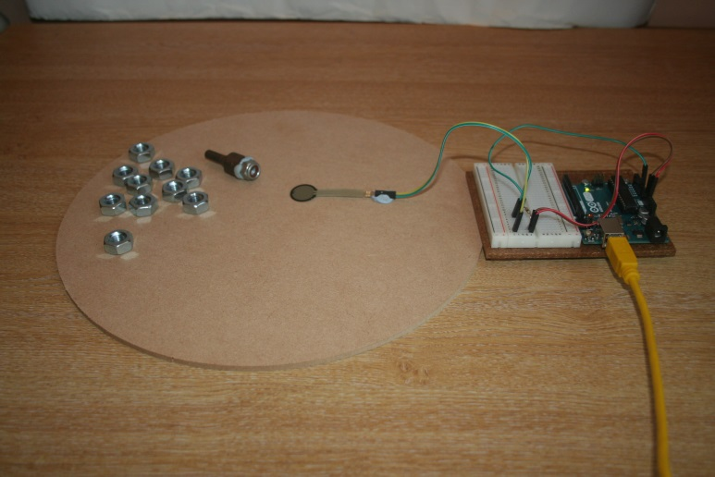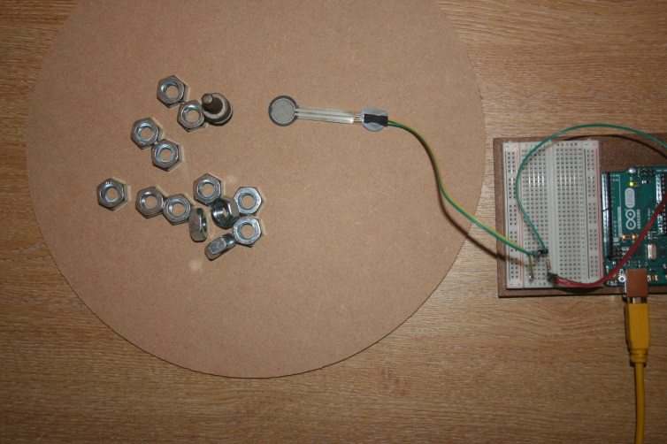
A
B
- An experiment was designed to determine if a force sensitive resistor (FSR) could be used to:
  - Test for the presence of a bird sized object on a bird table
  - Differentiate between different sized objects (e.g. a robin and a pigeon )
- The FSR used has a near infinite resistance which decreases as the force applied to it increases. The circuit used is called a potential divider. The potential difference (5V) is applied across the FSR and a 10k ohm resistor. When no force is applied and the FSR has near infinite resistance, all 5V will pass through the 10k ohm resistor. At the point where the FSR resistance is 10k ohm 2.5V will pass through the FSR and the 10K ohm resistor. Thus the PD passing through the FSR gives a measure of the force applied to it.
- The force sensitive resistor circuit was attached to a smooth board (A/B)
- A flat circular metal cylinder weighing 27g and with a diameter similar to the resistor was placed on top of the resistor (C)
- 15 metal nuts, each weighing 10g, were placed one at a time on top on the cylinder (D/E)
- Each time the output from the force sensitive resistor was recorded.

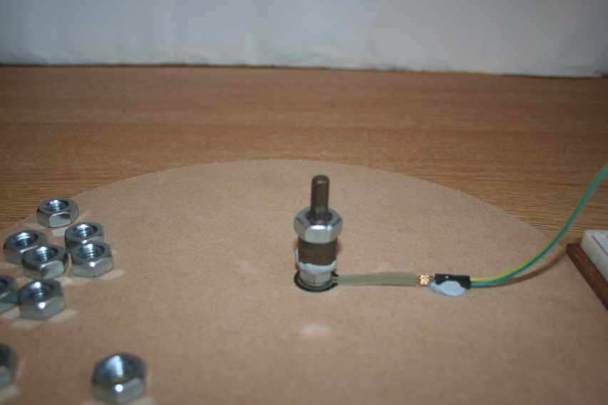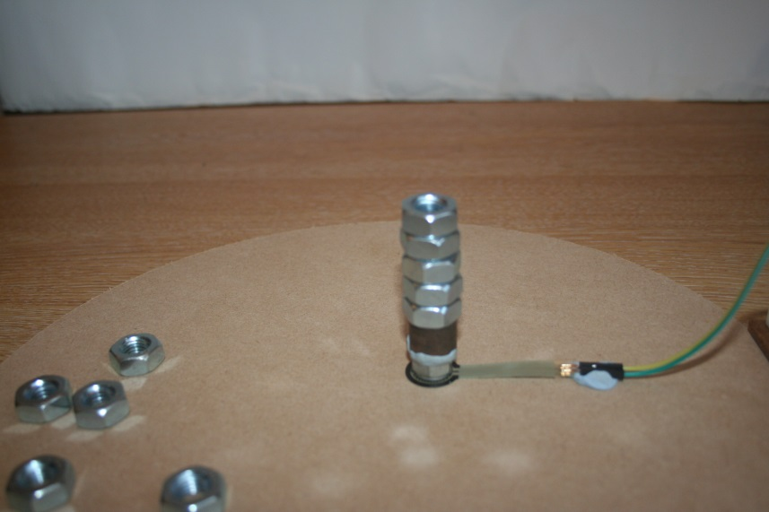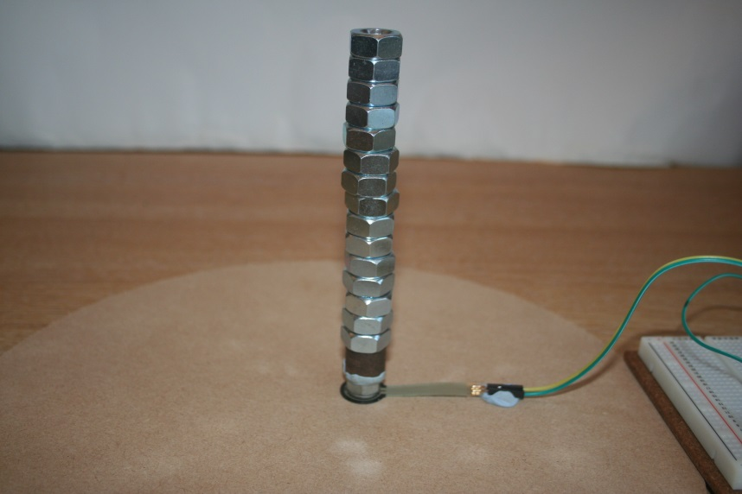
E
D
C

Circuit Diagram & Software
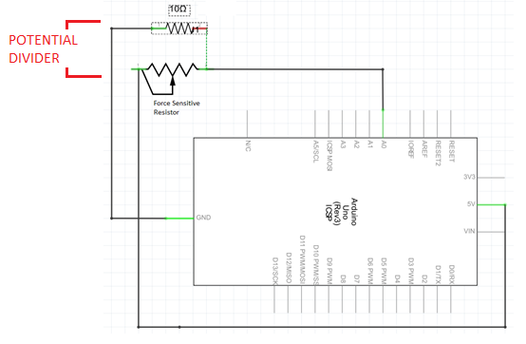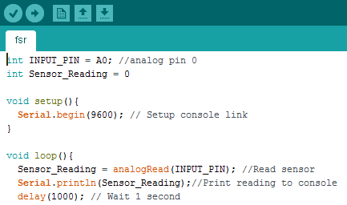
Results
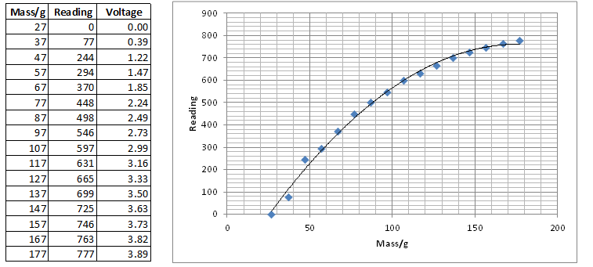
- The table and graph above show the results obtained. Note that with an Arduino analog port 5V = 1024 and 0V = 0
- The force applied was first detected in the region 27- 37g
- The FSR resistance decreased (i.e. the voltage passing through it increased) as the force applied increased and each 10g increase resulted in a significant change
- The relationship between FSR resistance and force applied is not linear. Above 200g the change caused by 10g would be negligible although by pushing hard on the FDR (10kg?) readings up to 1000 were observed

